National Council on Aging (NCOA) Falls Prevention Awareness Day is set for September 23, 2019.
The first day of fall, marks the 10th annual National Falls Prevention Awareness Day.

The Texas Physical Therapy Association (TPTA) would like everyone’s help in increasing the public’s awareness that falls are the leading cause of injury for older adults. Let’s help Texans
STAY ACTIVE AND FALLS FREE
This year we would like to have therapists and students participate in our
“So Long Sloppy Slippers” campaign.
This TPTA initiative encourages all physical therapists, physical therapist assistants, and students to do their part as healthcare providers, in helping to prevent falls among their clients, patients, friends, and family by asking all older adults 3 basic questions:
“Have you fallen in the past year?’
“Do you feel unsteady when standing or walking?”
“Do you worry about falling?”
If the answer to any of these questions is “yes”, then further screening, testing, and coordination of care should be conducted. It is estimated that on average, approximately 15 minutes should be allotted to complete each falls screening. A link to the CDC STEADI Initiative for Health Care Providers: https://www.cdc.gov/steadi/materials.html
The “So Long Sloppy Slippers” TPTA initiative will entail: collecting worn, potentially hazardous slippers from older adults, and conducting brief falls screens. If you do not wish to collect the slippers but wish to have a contest, you could have patients/clients take a picture of their “sloppy slippers”. Either way it creates an opportunity to discuss the importance of proper footwear for fall prevention. At the discretion of each individual PT entity/facility, older adult participants will be entered into a drawing for a chance to win a gift card to purchase a new pair of “Safe & Smart Slippers” or proper shoes. Each individual PT facility will be responsible for providing the funds for their gift card. The drawing for the winner would be on Fall Prevention Awareness Day, September 23rd. The slipper collection and falls risk screenings can take place for any designated time you wish but should be complete by September 23rd.
The CDC has a plethora of information available on fall prevention for clinicians as well as patients.
Screening and clinical tools:
https://www.cdc.gov/steadi/pdf/STEADI-Form-RiskFactorsCk-508.pdf
https://www.cdc.gov/steadi/pdf/STEADI-Algorithm-508.pdf
https://www.cdc.gov/steadi/pdf/STEADI-PocketGuide-508.pdf
https://www.cdc.gov/steadi/materials.html
Assessments:
https://www.cdc.gov/steadi/pdf/STEADI-Assessment-30Sec-508.pdf
https://www.cdc.gov/steadi/pdf/STEADI-Assessment-4Stage-508.pdf

One easy fix for families is to replace the sloppy slippers with a safe shoe and or a safe slipper.
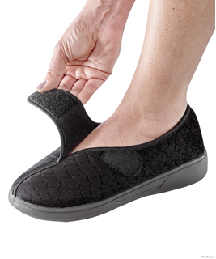
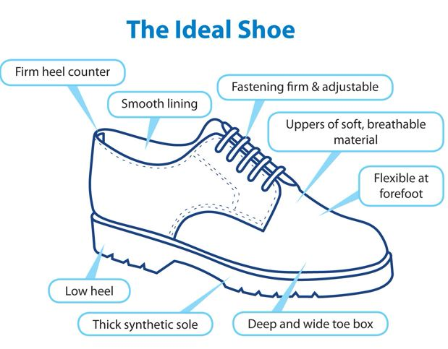
A Safer Slipper

Another great resource for information on Balance and Fall Prevention is the APTA consumer website.
www.MoveForwardPT.com
Click on the links below for information you can use and share with your patients/clients/family/friends.
Fall Prevention information:
PHYSICAL_THERAPIST_GUIDE_TO_FALLS
http://www.apta.org/Consumers/PatientHandouts/FallsPrevention/
Balance information:
PHYSICAL_THERAPIST_GUIDE_TO_BALANCE

Information on Community Resources for your patients:
It is highly recommended that each PT clinic/facility compile a list of some of the community-based fall prevention programs that are available in their local area, to provide to those who participate in their Falls Preventions Awareness Day event. Click the following link for a handy form on which to compile this information. https://www.cdc.gov/steadi/pdf/STEADI-Form-RecPrograms-508.pdf

